===================== Spring Cloud==========================

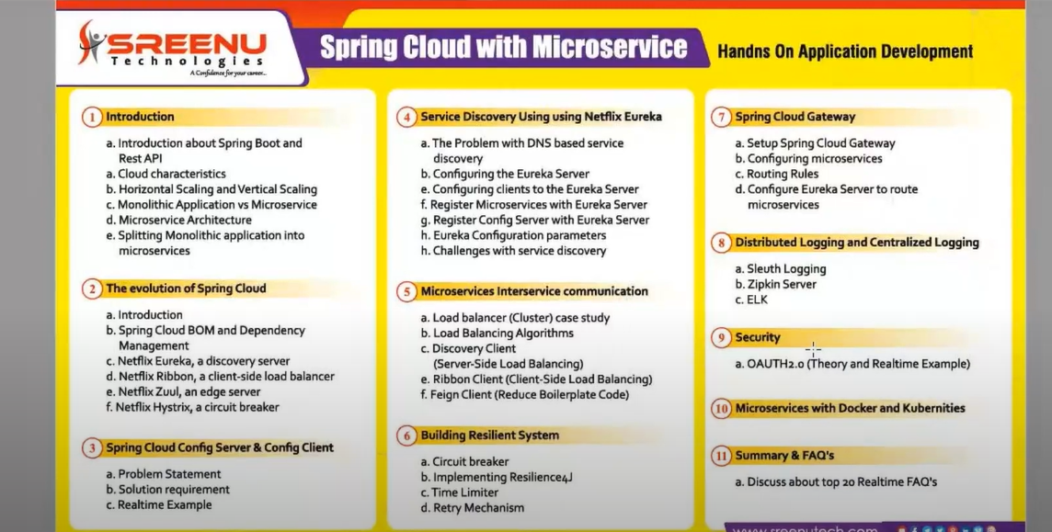

What is Vertical and Horizontal Scaling?
1. Vertical Scaling (Scaling Up):
Vertical scaling refers to adding more power (CPU, RAM, storage) to an existing machine to handle more load.
🟢 Example: Upgrading your server from 8 GB RAM to 32 GB RAM or from 4-core CPU to 16-core CPU.
✅ Pros:
Easier to implement.
No changes needed in application logic.
❌ Cons:
There is a limit to how much you can upgrade.
Single point of failure if the machine goes down.
Server meda traffic periginappudall RAM & CPU penchukuntu potham after some days ok vela traffic thaggithe anavasaram ga penchna danni maintain cheyataniki amout pettali.
2. Horizontal Scaling (Scaling Out):
Horizontal scaling refers to adding more machines (nodes/instances) to distribute the load across multiple systems.
🟢 Example: Deploying your Spring Boot application on 5 servers instead of just one.
✅ Pros:
Can handle very large traffic.
More fault-tolerant and highly available.
❌ Cons:
Requires load balancing.
Might require your application to be stateless or use shared storage/session.
Conclusion : Vertical Scaling is not good now a days prefer always Horizontal Scaling development only

Oka Microservices project devlop cheyali ante kavalisina resources
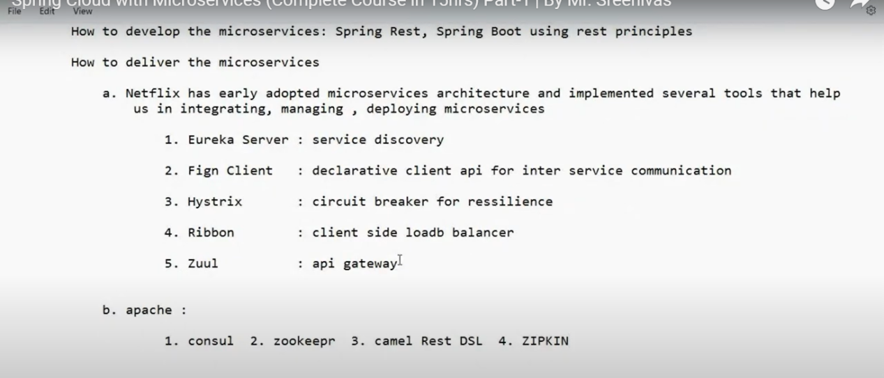
Old Micro-services version lo Netflix loni Tools ni vadi Microservices projects ni devlop chesevallu - dini valana boilerplate code repeted ga rayalsi vasthundi
So, E problems anni over-come cheyataniki spring thana own tool ni devlop chesindi instead of Netflix Tools ni replaces chesthu - andulo main Eureka & Spring Cloud
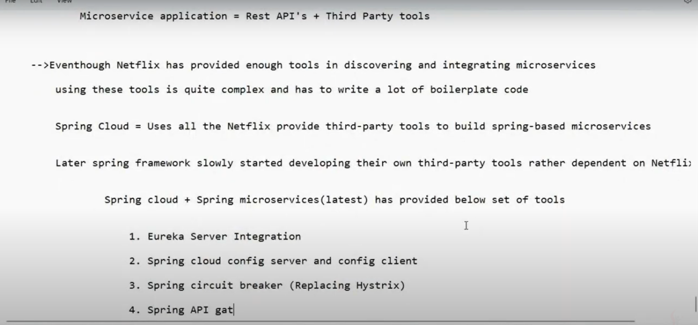
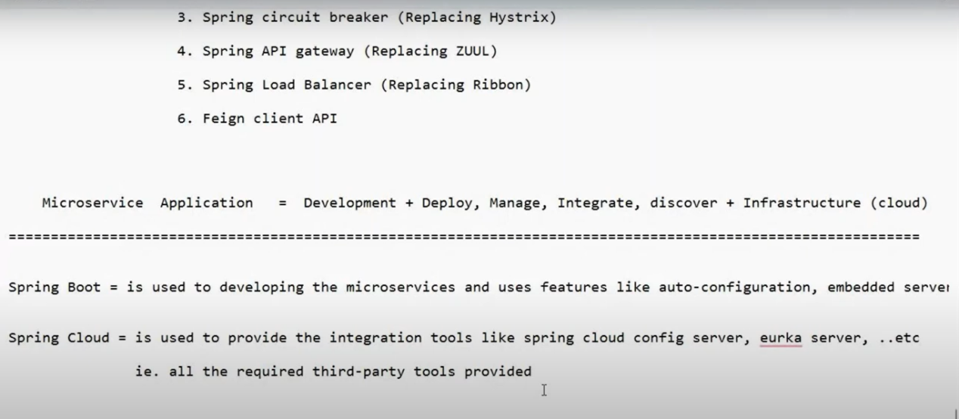
====================== Spring Cloud ==========================
Traditional Approach (Non-Containerized Microservices): Normal ga Project ki related Configuration(like: DB, URL’s ..etc ) antha application.properties file lo rastham ala rayatam valla yemanna changes chesthe project malli Re-build chesi Application Re-start cheyalsi vasthundi.
So, E problems anni over-come cheyataniki Containerized Approach anedi vacchindi.
Topic : Spring Cloud Configuration server
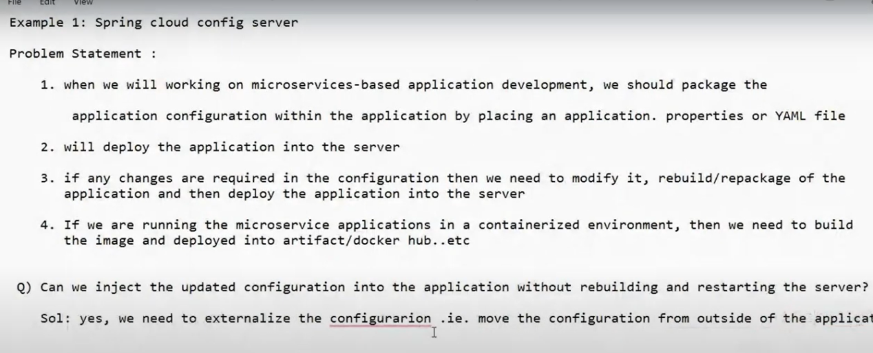
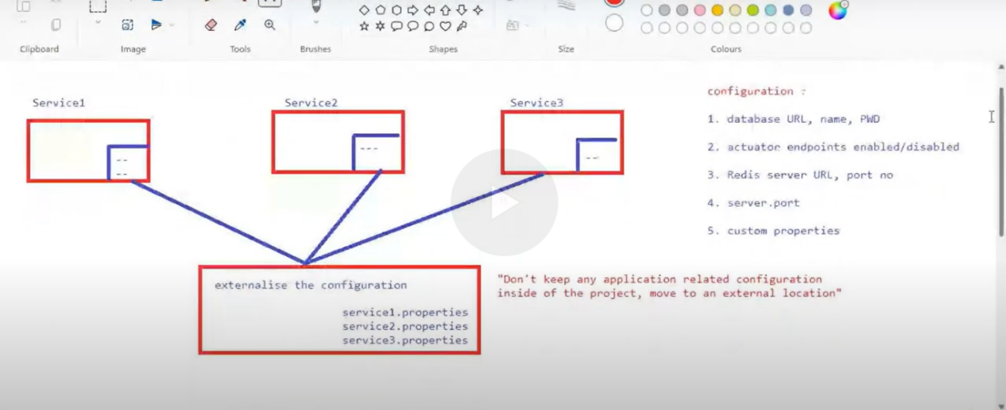

✅ Microservices Architecture with Spring Cloud Config, Docker & Kubernetes
Full Notes Summary – All Questions and Answers Covered

🔹 1. Microservices Basic Structure

Microservices Examples:
user-service
order-service
address-service

General Project Structure:
Each microservice usually contains:
- application.properties
- bootstrap.properties (only if using Spring Cloud Config)
- Dockerfile
- pom.xml

2. Centralized Configuration using Spring Cloud Config

✅ Why Use It?
To externalize and centralize configuration for all microservices, so:
Shared configs are defined once
No need to redeploy apps for config changes
Easy to manage environment-specific values (dev, prod, etc.)

Key Components
Component | Description
config-server | A Spring Boot project that serves .properties files from a remote Git repo
config-repo | A GitHub repo (or local folder) where all configuration files live
bootstrap.properties | Tells microservices how to connect to config-server and which config to load
application.properties in config-repo | Global config shared across all services
user-service.properties | Service-specific config for user-service
order-service.properties | Service-specific config for order-service

3. File Purpose – Explained One by One
File | Where It Lives | Purpose
application.properties (config-repo) | Shared global settings like logging, date formats, Eureka URL
user-service.properties | In config-repo | Holds service-specific config (like DB URL, port, keys)
order-service.properties | In config-repo | Same as above for order-service
bootstrap.properties | Inside each microservice | Used to fetch config from config-server
application.properties (inside microservice) | Used only when not using Spring Cloud Config or to override further
config-server’s application.properties | Tells Spring where the Git config repo is and what branch to use

Example bootstrap.properties (inside user-service)
spring.application.name=user-service
spring.cloud.config.uri=http://localhost:8888 ---> config-server(Spring Cloud configuration kosam - Git location PSW& Username tho) kosam oka project create chestam a Port NUB ni bootstrap.properties file lo rastham

Example config-server config
server.port=8888 ---> Spring cloud configuration project
spring.cloud.config.server.git.uri=https://github.com/my-org/config-repo
spring.cloud.config.server.git.default-label=main

🔹 4. How Configuration Works (Flow)
user-service starts
↓
Reads bootstrap.properties
↓
Contacts config-server at http://localhost:8888
↓
Asks for config: GET /user-service/default
↓
config-server fetches:
- application.properties (global config)
- user-service.properties (service -specific)
↓
Spring merges both → sends final config back to user-service
✅ Result: Microservice uses config without hardcoding values

5. Role of Each Tool in Real-Time Setup
Tool | Role
Spring Cloud Config Server | Centralized config delivery
GitHub | Stores all configuration files (config-repo)
Docker | Creates container images for each microservice
Kubernetes (K8s) | Deploys and manages the containers at scale
Docker Compose | Local development and testing with all services up

6. Global Config (application.properties) – What to Put

✅ Real Use Cases:
logging.level.root=INFO
eureka.client.service-url.defaultZone=http://eureka-server:8761/eureka/
gateway.api.key=global-shared-key
spring.jackson.date-format=yyyy-MM-dd
spring.datasource.hikari.maximum-pool-size=10
✅ These apply to all microservices, unless overridden.
Conclusion : Simple ga chepali ante All microservices Project ki vade common Properties ni e Global Configuration properties file lo rayali ala rayatam valla individual ga Microservices projects lo rase avasaram vundadu…..
So, Common ga vude properties eila separate chesi rayali..

7. Difference Between Two Architecture Flows

Flow 1: Traditional Setup (without external config)
Each microservice has its own application.properties
Config is hardcoded
No centralized config control
Changing a config requires restarting the service

Flow 2: Modern Setup (with Spring Cloud Config + Docker/K8s)
Config moved out of codebase into a Git repo
One central config-server serves config to all microservices
Config is updated without redeploy ---> eila restart cheyakunda update Configuration ni use cheyali ante code lo @RefreshScope ni use cheyali
Works well with Docker & Kubernetes
✅ 🔥 Modern real-time projects use Flow 2 (with Spring Cloud Config + Docker + K8s)

8. Summary of Folder Structure (Modern Architecture)
spring-microservices-app/
│
├── docker-compose.yml <-- Runs all services locally
│
├── config-server/ <-- Spring Boot app(ConfigServer)
│ ├── src/
│ ├── application.properties <-- Points to config-repo
│
├── config-repo/ <-- Git repo (external config)
│ ├── application.properties <-- Global config
│ ├── user-service.properties <-- user-service config
│ ├── order-service.properties <-- order-service config
│
├── user-service/ <-- Actual microservice
│ ├── src/
│ ├── bootstrap.properties <-- Loads config from config-server
│ ├── Dockerfile
│
├── order-service/ <-- Another microservice
│ ├── src/
│ ├── bootstrap.properties
│ ├── Dockerfile

🔹 9. Key Points to Remember
✅ Central config reduces duplication
✅ Spring automatically merges global + service-specific configs
✅ @Value or @ConfigurationProperties helps inject values
✅ Config can be refreshed using @RefreshScope
✅ spring.application.name = service file name in config-repo
✅ config-server handles all config delivery
✅ Docker builds images
✅ K8s deploys and scales them
✅ GitHub stores both code and config
✅ Yes — the notes I provided cover the entire discussion we had from the beginning to the end. Below is a quick checklist cross-verified with every topic you asked, confirming nothing is missed:

✅ Topic-by-Topic Coverage Checklist
Topic You Asked | Covered in Notes? | Where It’s Covered
Each microservice having its own application.properties | ✅ | Section 1
Spring Cloud Config — why & where it’s used | ✅ | Section 2
bootstrap.properties and its role | ✅ | Section 2 & 4
application.properties (global) — what to write & use cases | ✅ | Section 6
Difference between application.properties and service-specific .properties files | ✅ | Section 3 & 6
config-server and config-repo project roles | ✅ | Section 2 & 4
Folder structure of real-time architecture | ✅ | Section 8
Purpose of Docker, Kubernetes, GitHub | ✅ | Section 5
Your doubt: "Do we restart service if config changes?" | ✅ | Mentioned in Flow 1 vs Flow 2
Flow of config loading: how microservice gets merged config | ✅ | Section 4
Clarification of global vs service-level config (merge rules) | ✅ | Section 3 & 4
Real example for logging, Eureka, API keys in global config | ✅ | Section 6
Modern architecture used in companies today | ✅ | Section 7
Difference between your observed project vs modern cloud-native setup | ✅ | Section 7
Role of each tool in the ecosystem | ✅ | Section 5
Real folder structure, what to put where | ✅ | Section 8
Final summary + memory tips | ✅ | Section 9

Eppati daka Spring Cloud Configuration server + Docker+K8s ni use chesi Microservices projects Architecture chusam
Now actual ga Spring Cloud Configuration server ni use chesthe properties configuration lo yemanna changes chesinappudu application ni Re-start cheyakunda ne updated changes tho application ni use cheyachhu.
Now Topic : with out Re-start providing updated config changes to application + DB credentials Encryption & Description cheyatam.

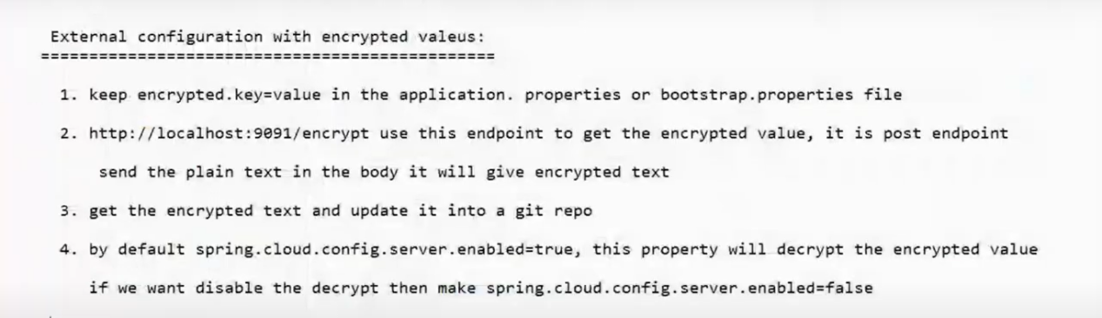
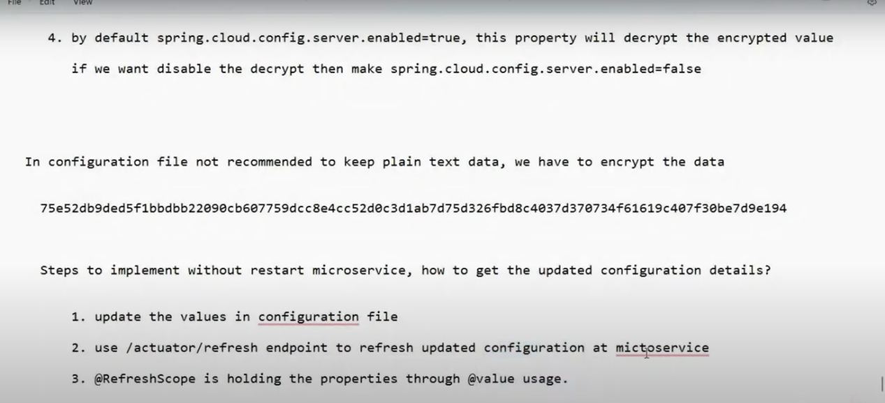
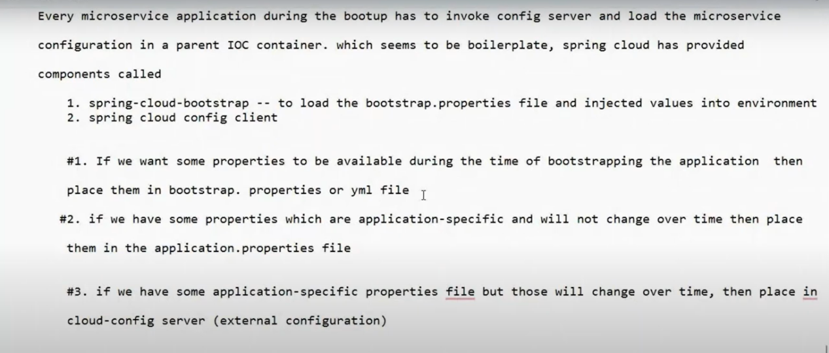

============================== END - Configuration topic ==================

---------------------------------- Eureka Server Topic -----------------------------------

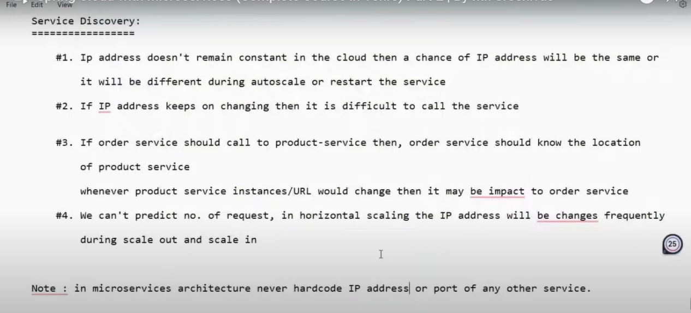
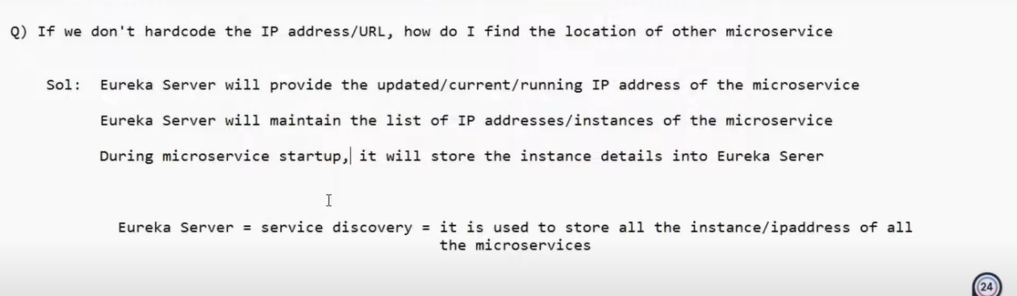

✅ Simple Conclusion:
In a microservices project, instead of hardcoding IPs and ports for each service, we use Eureka (Service Discovery) so that services can find and talk to each other by name automatically, even if their IPs or ports change.

Nothing but manam oka microserivces project ni Eureka service lo rigister chesi yenni ports kavli ante anni ports tho run cheyachhu

Diagram :

Flow of Euraka server Registation anedi yela vuntadi and 2 microservices anevi yela communicate avuthay & oka vera microservices project anevi Multiple instances (multipleports mida run avithe ) Eureka lo yela righter Avuthayy ane compleate topic EDI

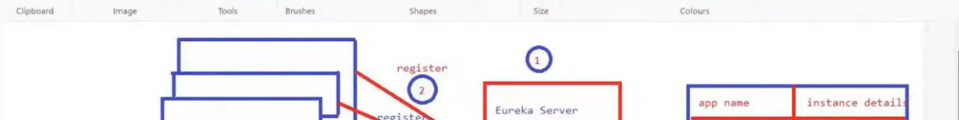
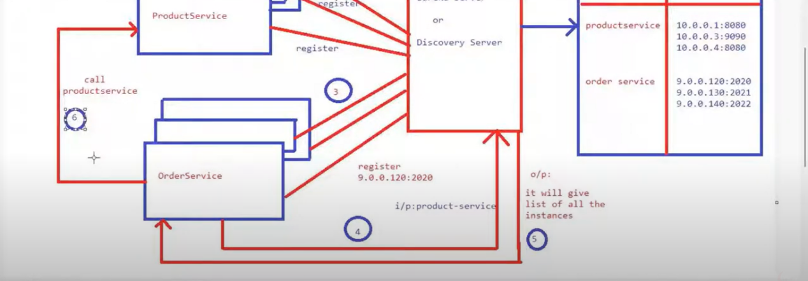

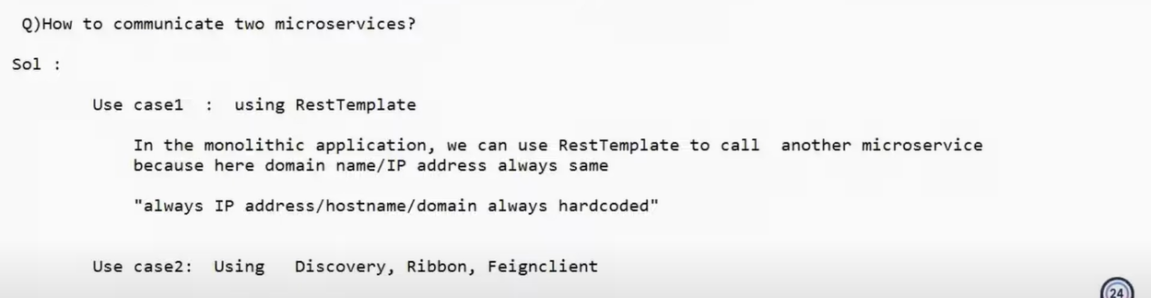

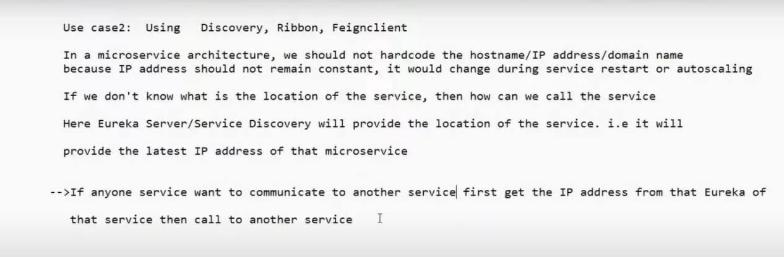

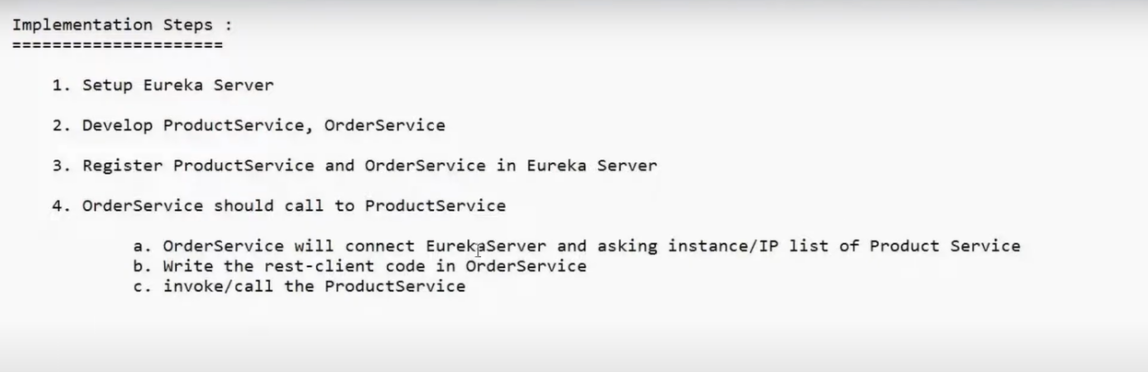

Eureka server ni register cheyataniki properties
Alreay “Using Eureka in Microservices projects “ ane project chesanu clear ga

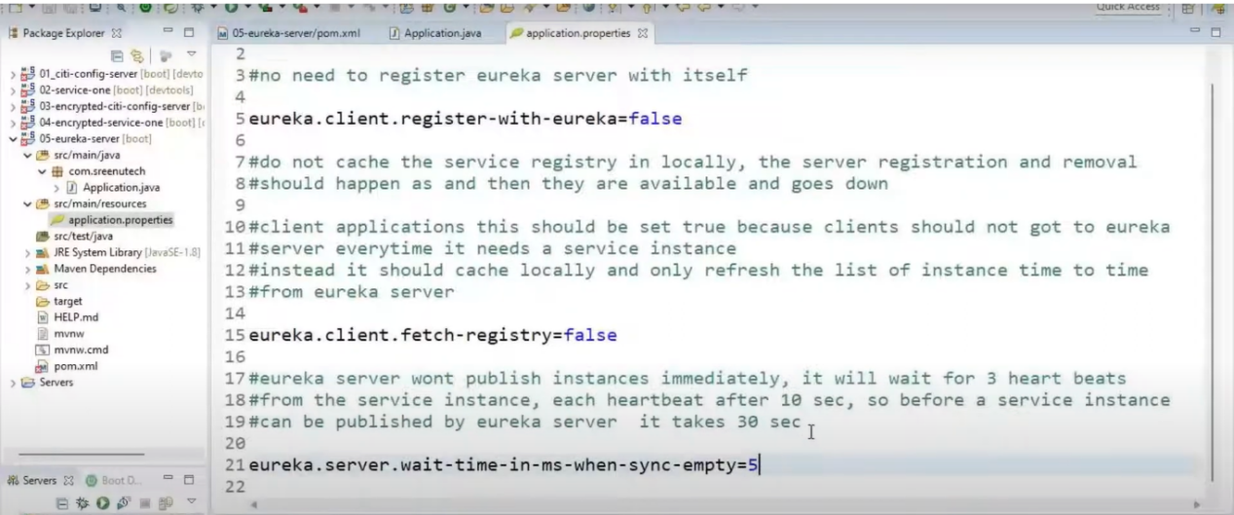

But E propertie TAG nenu rayaledu

eureka.server.wait-time-in-ms-when-sync-empty=5
Microservices project create chesaka vatini Eureka server lo rigister chestahm kada eppatidaka Oka Eureka server ye vuntadi anukunnam but Microservices project ki multiple instance yela create chestahmo same alane Eureka server ki kuda multiple Instance create cheyachhu Ala cheyatanni Eureka cluster behaviour antaru

So Eureka cluster behaviour ki E tag ki link yenti eureka.server.wait-time-in-ms-when-sync-empty=5

Eureka server ni Multiple instance tho create chesinappudu.. oka server start chesaka adi veroka server ki connect avuthundi ala syn avvatam anedi 5 ms aginaka syn avvtaniki server try cheyali ani

📘 Eureka Multiple Instances – Complete Notes

1. What is Eureka in Spring Cloud?
Eureka is a service discovery server used in microservices architecture. It allows services to:
Register themselves (so others can find them)
Discover other services dynamically

2. Vertical vs Horizontal Scaling (Conceptual)
Vertical Scaling: Increase resources (CPU/RAM) of a single instance
Horizontal Scaling: Run multiple instances of services or servers on different ports/machines
Eureka supports horizontal scaling through multiple server instances.

3. Why Multiple Eureka Instances?
To ensure:
High availability
Load balancing
Failover when one Eureka server goes down
This setup is often called a Eureka cluster or peer-aware Eureka servers.

4. Eureka Server Configuration – Single vs Cluster

✅ Single Eureka Server:
eureka.client.register-with-eureka=false
eureka.client.fetch-registry=false
Does not sync with any peers
Not fault-tolerant

✅ Clustered Eureka Server (Peer Mode):
eureka.client.register-with-eureka=true
eureka.client.fetch-registry=true
eureka.client.service-url.defaultZone=http://localhost:8762/eureka/,http://localhost:8763/eureka/
eureka.server.wait-time-in-ms-when-sync-empty=5
Registers and syncs with other Eureka servers
Fault-tolerant and scalable

🔄 5. eureka.server.wait-time-in-ms-when-sync-empty=5
Used during Eureka startup
If Eureka can't get registry data from peers (they're down or empty), it waits 5 ms before trying again
Eureka will retry in a loop until it gets data
✅ Applies only during startup, not during runtime failures

6. Eureka Peer Sync Behavior
Each Eureka server:
Uses the defaultZone list to know its peer Eureka servers
Tries to fetch registry from all listed peers
If at least one peer is up, Eureka proceeds
If all peers are down, it waits (based on the wait-time setting)
✅ Eureka does not need all peers to be up — one is enough.

🏗️ 7. Configuring Separate Eureka Instances
To run multiple Eureka servers (Eu-1, Eu-2, Eu-3), use separate configs using:

Option 1: Spring Profiles
application-eu1.properties
application-eu2.properties
application-eu3.properties
Each file should include:
server.port=PORT
spring.profiles.active=euX
eureka.client.register-with-eureka=true
eureka.client.fetch-registry=true
eureka.client.service-url.defaultZone=http://other-eurekas/eureka/

Option 2: Command-line overrides
java -jar eureka.jar --server.port=8762 --spring.profiles.active=eu2 ...

8. Microservice Configuration for Eureka
Each microservice should register with multiple Eureka servers:
eureka.client.service-url.defaultZone=http://localhost:8761/eureka/,http://localhost:8762/eureka/,http://localhost:8763/eureka/
✅ This ensures:
If one Eureka goes down, the service still works
Auto-failover and load-balancing behavior

9. What if Eureka Server Goes Down?
Clients cache registry data locally
If Eureka is down, discovery still works for a short time
After cache expires, service discovery will fail
✅ Multiple Eureka URLs in defaultZone helps avoid this
Simple ga cheppali ante : peers anevi below tag tho difine chesthamu (kavali ante Every Eureka ki separete ga declare cheyachhu ) yela avithe microservices projects ki rasthamo
url.defaultZone=http://localhost:8761/eureka/,http://localhost:8762/eureka/,http://localhost:8763/eureka/
So Eu-1 ni start chesam Eu-2 down lo vundi Eu-3 UP lo vundi ala vunappudu Eu-1 Wait cheyadu because any one server (Peer) up lo vunte chalu Yeppudu Eu-1 Wait chesthundi ante define chesina ye server up lo lekunte appudu echhina time varaku wait chesi connect avvataniki try chesthundi ala yedo oka server UP avvedaka loop lo wait chesthu connect avvataniki try chusthundi.

When does eureka.server.wait-time-in-ms-when-sync-empty=5 actually apply?
Only if none of the peers return registry data (i.e., all are down or return an empty registry)
In that case, Eureka waits 5ms and retries — this continues in a loop until at least one peer responds with registry

10. Typical Mistakes and Fixes
Mistake | Fix
Only one Eureka server used | Use 2–3 instances in a cluster
Microservice connects to just one Eureka | Connect to multiple via defaultZone
Eureka servers not syncing | Check register-with-eureka and fetch-registry are both true
Confusion about wait-time | Remember: it's only for startup sync

11. Final Real-World Recommendation
Deploy 3 Eureka servers in a cluster
Run each on a separate port/machine/container
Ensure each Eureka knows about its peers
Register each microservice with multiple Eurekas
Use a load balancer or DNS in production instead of hardcoded localhost URLs
✅ You're Now Ready to Design and Run Fault-Tolerant Eureka Clusters in
Fault-Tolerant Eureka Clusters :A setup of multiple Eureka servers that can continue working (serving registry and discovery) even if one or more of them fail.
Simple ga cheppali ante pyna vunna concpets anniti ni use chesi Oka server down lo vunna application down avvakunda Up lo vunna server tho work avvela cheyatame

Multiple microservices project oka danitho okati configure avvataniki below properties tgs use cheyali
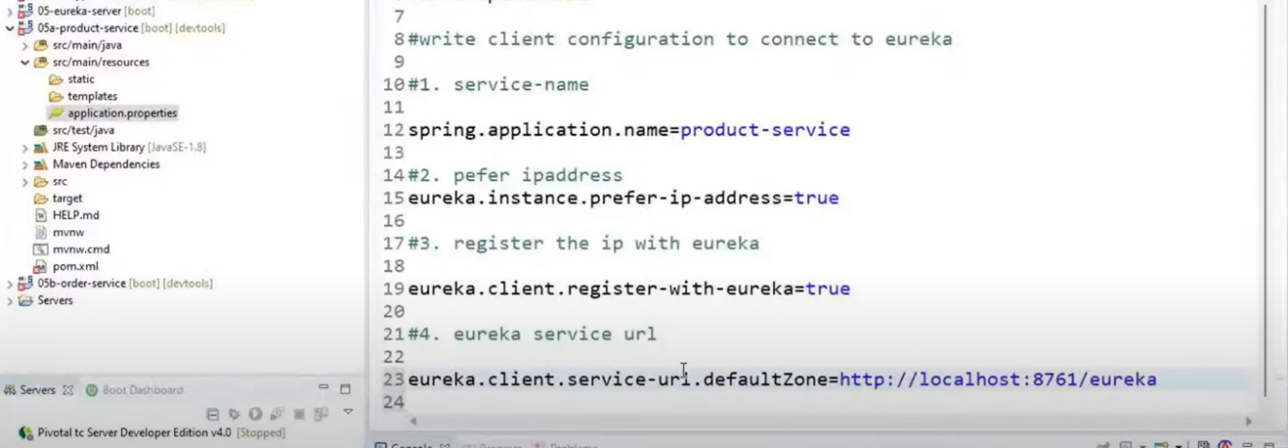

========================= Load balancer ========================

Load balancer : Microservices projects ni Multiple Instances tho run chesthunappudu Request anevi Okate port ki vellakunda distribute cheyataniki Load balancer ni use chesthamu
But,
Load balancer ni define cheyakunte Eureka Server default ga Server-side load balancer ni use chesukuntadi
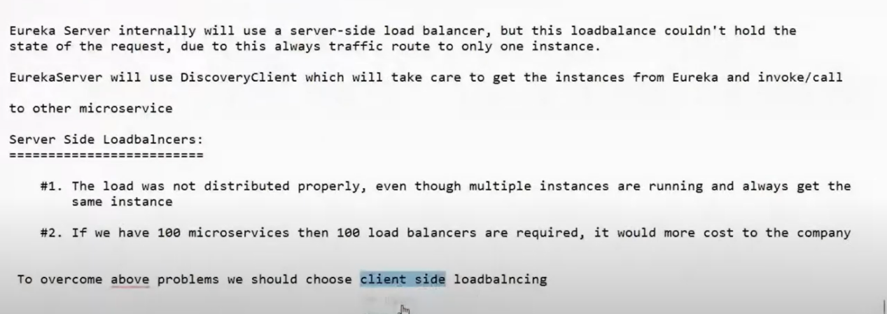

Loadbalncer Topic: Diniki dedicate video chusanu (Easy lerning chanal) and project chesanu

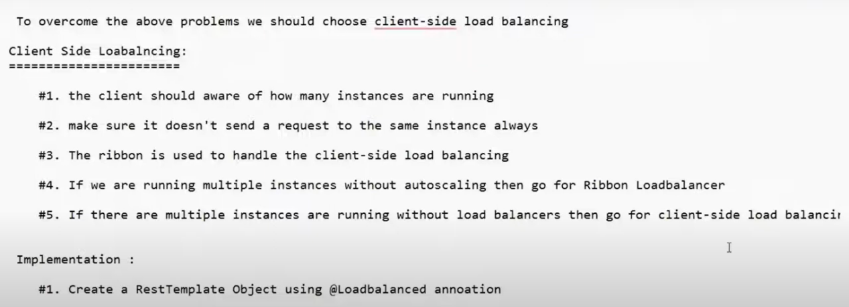
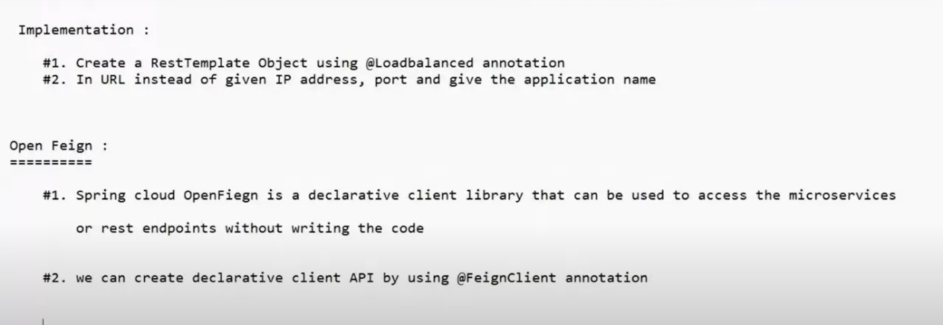

Oka 2 microservices oka danitho okati commuicate avvali ante @FeignClient ni use cheyali… Appude 2 microservices projects communicate avuthayy…
Diniki Oka deticate project Chesanu..
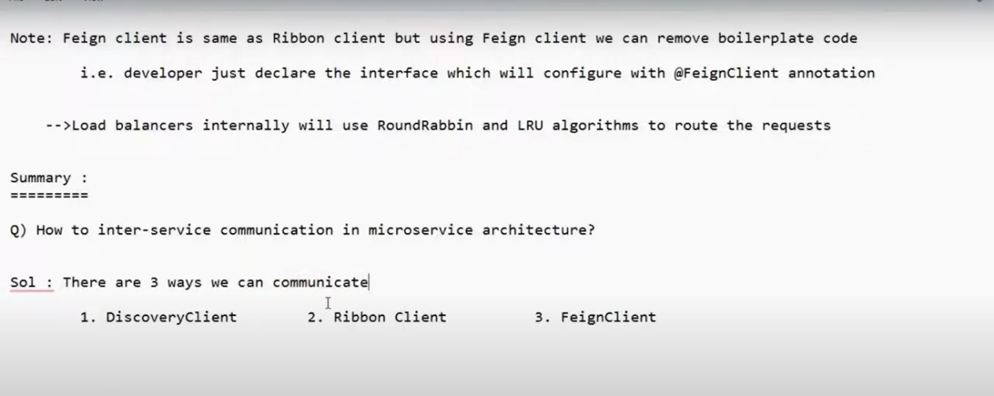

Spring Cloud gateway ki dedicate video chusanu (Easy lerning chanal) and project chesanu
Note : Spring Cloud gateway ni use chesthe Loadbalncer ki vere code rayalsina avasaram ledu Spring Cloud gateway ne atomatic ga difine chesukuntadi

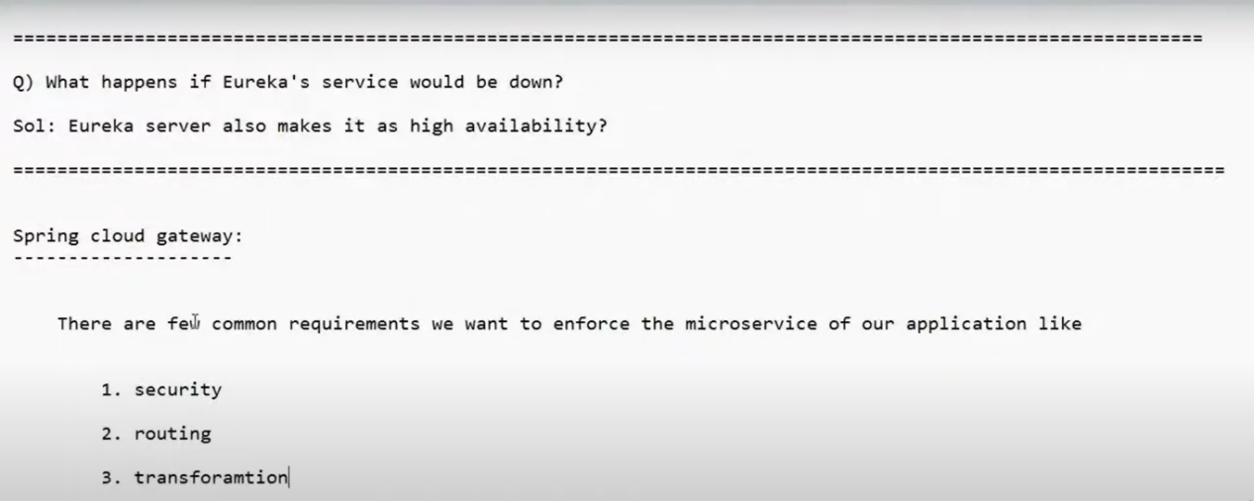
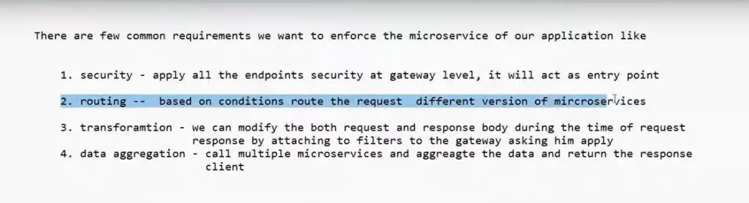

============== Circuit breaker concept in Microservice =================
Spring Cloud gateway ki dedicate video chusanu (Easy lerning chanal) and project chesanu

Microservices distributed topic

Multiple microservices anevi oka dani nuodi okati call avuthu vuntayy….ala call chesinappudu yedanna oka services anedi work avvakunte danni simple ga troubleshoot chesi check cheyataniki E Zipkin and Slueth ni use chesthamu
Conclustion : simplega pom.xml lo dipendences add chesi
Zipkin jar ni start chesi default URL ni use chesthe log’s details print avuthayyy..
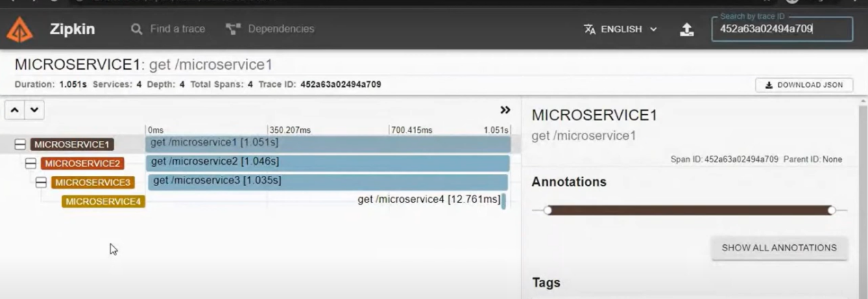

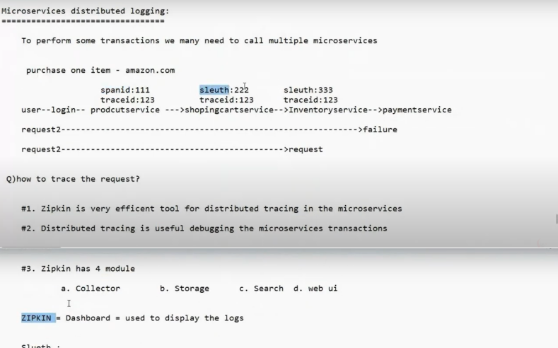

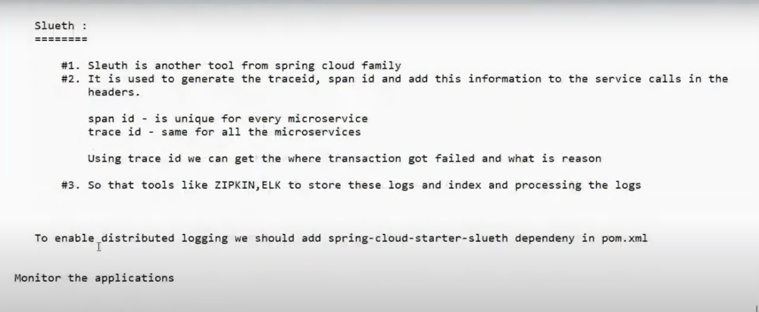

===================================== Topic clarity ==================================

Project GitHub account, folders and projects structure and details?

✅ STEP 1: Log into GitHub
Once you log into your GitHub account, you’ll land on your GitHub dashboard.

🔷 GitHub Dashboard Example:
Welcome, YourName!
[+ New] [Repositories] [Stars] [Explore] ...

Repositories
-------------
📁 spring-microservices-app

✅ STEP 2: Click on Your Repository
You will see your main repo:
📁 spring-microservices-app
Click on it.

✅ STEP 3: Inside Repository – Folder View
Once inside spring-microservices-app, here’s the exact folder layout you will see on the GitHub file explorer:
spring-microservices-app/
│
├── docker-compose.yml <-- Runs all services
│
├── config-server/ <-- Spring Boot App (Config Server)
│ └── src/
│ └── application.properties
│
├── config-repo/ <-- Folder acting as config Git repo
│ └── application.properties
│ └── user-service.properties
│ └── order-service.properties
│ └── eureka-server.properties
│
├── eureka-server/ <-- Spring Boot App (Eureka)
│ └── src/
│ └── application.properties
│
├── user-service/ <-- Microservice: User
│ └── src/
│ └── bootstrap.properties
│ └── Dockerfile
│
├── order-service/ <-- Microservice: Order
│ └── src/
│ └── bootstrap.properties
│ └── Dockerfile

STEP 4: Configuration Mapping Table
Here is a clear table showing:
🔧 Each project folder
🧩 Its purpose
📄 The config files it uses
📁 Folder | 🧩 Purpose / Role | 📄 Config Files Used | 🔁 Depends On
config-server/ | Loads config from config-repo | application.properties (points to repo) | config-repo/
config-repo/ | Stores config for all services | application.properties (global), service-specific .properties | Used by config-server
eureka-server/ | Registers services for discovery | application.properties | config-server/
user-service/ | User microservice | bootstrap.properties (for config), via config-server | config-server/, eureka-server/
order-service/ | Order microservice | bootstrap.properties (for config), via config-server | config-server/, eureka-server/
docker-compose.yml | Starts all services together | N/A | All apps

📁 Example: config-repo/ Contents
This simulates a Git-based config repository:
config-repo/
├── application.properties <-- Global config for all services
├── user-service.properties <-- Config for user-service only
├── order-service.properties <-- Config for order-service only
├── eureka-server.properties <-- Config for eureka-server only
All services will load from here via config-server/.

Summary Chart
GitHub Account
└── Repository: spring-microservices-app
├── docker-compose.yml
├── config-server/
│ └── application.properties
├── config-repo/
│ ├── application.properties
│ ├── user-service.properties
│ ├── order-service.properties
│ └── eureka-server.properties
├── eureka-server/
│ └── application.properties
├── user-service/
│ └── bootstrap.properties
├── order-service/
│ └── bootstrap.properties

config-server/ and eureka-server/ in side and config details ?

Great question — you're almost right, and you're thinking in the right direction. Let's go deeper and give you pin-to-pin clarity 🔍 on both:

✅ 1. config-server/ — Spring Boot Project

✔️ Purpose:
This is a Spring Cloud Config Server that serves configuration files to your microservices (like user-service, order-service, etc.) from a Git-backed repository (in your case, a folder named config-repo/).

✔️ What You Actually Do Here:
✅ Task | 📄 Where it's done | 💡 Details
Add Spring Boot starter for config server | pom.xml or build.gradle | Dependency: spring-cloud-config-server
Enable config server | @EnableConfigServer in MainApplication.java | One-line annotation
Git repo path or GitHub token | application.properties | Set path or GitHub URL with credentials
No controller/service/repo code | No custom logic | ✅ Yes, mostly config-only

📄 Sample ConfigServerApplication.java:
@SpringBootApplication
@EnableConfigServer
public class ConfigServerApplication {
public static void main(String[] args) {
SpringApplication.run(ConfigServerApplication.class, args);
}
}

📄 Sample application.properties:
server.port=8888
spring.cloud.config.server.git.uri=file://../config-repo
# If using GitHub:
# spring.cloud.config.server.git.uri=https://github.com/your-org/config-repo
# spring.cloud.config.server.git.username=your-username
# spring.cloud.config.server.git.password=your-token
✅ No business logic, no services, no controllers — only configuration.

✅ 2. eureka-server/ — Spring Boot Project

✔️ Purpose:
This is a Spring Cloud Eureka Server that acts as a service registry. All other microservices will register themselves here so they can discover each other.

✔️ What You Actually Do Here:
✅ Task | 📄 Where it's done | 💡 Details
Add Eureka server dependency | pom.xml or build.gradle | spring-cloud-starter-netflix-eureka-server
Enable Eureka server | @EnableEurekaServer in MainApplication.java | One-line annotation
Configure self-registry off | application.properties | Don’t register Eureka with itself
No controller/service/repo code | No custom logic | ✅ Only registry config

📄 Sample EurekaServerApplication.java:
@SpringBootApplication
@EnableEurekaServer
public class EurekaServerApplication {
public static void main(String[] args) {
SpringApplication.run(EurekaServerApplication.class, args);
}
}

📄 Sample application.properties:
server.port=8761
eureka.client.register-with-eureka=false
eureka.client.fetch-registry=false
✅ Again — no Java business logic. Only config and one main class.

Summary Table
Folder | Is it Spring Boot Project? | Contains Java Code? | Contains Logic? | What You Write
config-server/ | ✅ Yes | ✅ Only 1 class | ❌ No logic | @EnableConfigServer, config properties
eureka-server/ | ✅ Yes | ✅ Only 1 class | ❌ No logic | @EnableEurekaServer, config properties
Microservices | ✅ Yes | ✅ Full code | ✅ Yes | Controller, Service, Repository, etc.
So you're correct: both config-server/ and eureka-server/ are Spring Boot apps, but you write only minimal code — mostly configuration.

all properties files and boot stram files example configuration with real word basis ?

Excellent! You're asking the right questions. Let's clear all confusion with:
🔍 A simple explanation of spring.cloud.config.server.git.uri
🔧 The real-world role of config-server/
🧾 Full examples of application.properties and bootstrap.properties for all services

✅ 1. What is spring.cloud.config.server.git.uri=file://../config-repo?
This line tells the Spring Cloud Config Server where to find the configuration files it should serve to other microservices.

🔍 Breakdown:
spring.cloud.config.server.git.uri: This is the property that tells Spring where to find the config repo.
file://../config-repo: Means your config files are stored locally, in a folder named config-repo one level up from the config server.
✅ If you were using GitHub instead, you’d write:
spring.cloud.config.server.git.uri=https://github.com/your-org/config-repo

✅ 2. What is config-server/ really doing?
The config-server/ is a Spring Boot project that:
Listens on port 8888
Reads config files (from config-repo)
Provides those config files to other services dynamically via HTTP
Helps centralize config management (✅ one place to update values like DB URLs, ports, feature flags, etc.)
It acts like a configuration API. Your microservices call it at startup to get their settings.

✅ 3. Real-World Config Example for All Projects
Let’s assume the project folder structure is:
spring-microservices-app/
├── config-server/
├── config-repo/
├── eureka-server/
├── user-service/
├── order-service/

📁 config-server/application.properties
server.port=8888

# Where config-server looks for config files
spring.cloud.config.server.git.uri=file://../config-repo
# If using GitHub, use:
# spring.cloud.config.server.git.uri=https://github.com/your-org/config-repo
# spring.cloud.config.server.git.username=your-username
# spring.cloud.config.server.git.password=your-access-token

📁 config-repo/ (local folder, acts like Git repo)

application.properties (global config)
management.endpoints.web.exposure.include=*
spring.application.name=global-config

user-service.properties
server.port=8081
spring.application.name=user-service
eureka.client.service-url.defaultZone=http://localhost:8761/eureka

order-service.properties
server.port=8082
spring.application.name=order-service
eureka.client.service-url.defaultZone=http://localhost:8761/eureka

eureka-server.properties
server.port=8761
spring.application.name=eureka-server
eureka.client.register-with-eureka=false
eureka.client.fetch-registry=false

📁 user-service/bootstrap.properties
spring.application.name=user-service
spring.cloud.config.uri=http://localhost:8888

📁 order-service/bootstrap.properties
spring.application.name=order-service
spring.cloud.config.uri=http://localhost:8888

📁 eureka-server/bootstrap.properties
spring.application.name=eureka-server
spring.cloud.config.uri=http://localhost:8888

Final Flow
🟢 You start the config-server on port 8888.
🟦 Each microservice (user-service, order-service, eureka-server) starts up and reads its bootstrap.properties:
Connects to http://localhost:8888
Sends its name (e.g., user-service)
📁 Config Server reads user-service.properties from config-repo/ and gives it back.
🔄 Now the service is configured with the right port, Eureka settings, DB URLs, etc.

✅ Recap
Folder | File | Key Purpose
config-server/ | application.properties | Points to config-repo (local or GitHub)
config-repo/ | *.properties files | Central config per service + global file
user-service/ | bootstrap.properties | Requests config from config-server
order-service/ | bootstrap.properties | Requests config from config-server
eureka-server/ | bootstrap.properties | Requests config from config-server

✅ Final Flow of Spring Cloud Microservices (Config + Eureka)
Let’s break this down like a story with clear roles:

🟢 Step 1: You have a config-server project
Role | Purpose
🔧 config-server | A Spring Boot app (port 8888) that reads config files from a Git repo or local folder (config-repo/) and shares them with other services
📄 It uses:
spring.cloud.config.server.git.uri=file://../config-repo
Or (if GitHub):
spring.cloud.config.server.git.uri=https://github.com/org/config-repo

🟦 Step 2: You have user-service, order-service, etc. (microservices)
Each of these services has a small config file at first:
📄 bootstrap.properties (not application.properties yet!)
spring.application.name=user-service
spring.cloud.config.uri=http://localhost:8888
This tells the service:
"Hey, go ask the config-server at port 8888 for your real config."

🔁 Step 3: Microservice calls config-server at startup
It says:
“Hi, I’m user-service. Do you have my config?”
config-server then looks inside:
config-repo/user-service.properties
Returns:
server.port=8081
eureka.client.service-url.defaultZone=http://localhost:8761/eureka
So now:
Service runs on port 8081
Knows where Eureka is (port 8761)

🟨 Step 4: Eureka Server
Role | Purpose
🛰️ eureka-server | A Spring Boot app (port 8761) that acts as the service registry. Every microservice registers itself here.
It uses config from:
Its own bootstrap.properties (to connect to config-server)
Its own file in config-repo/eureka-server.properties

🔁 Complete Lifecycle on App Startup

For a microservice like user-service:
🗂 Reads bootstrap.properties
Connects to http://localhost:8888 (config-server)
🔗 Config-server fetches user-service.properties from config-repo
⚙️ Now it knows:
What port to run on
Eureka registration URL
🔗 Registers with Eureka at http://localhost:8761/eureka
✅ Ready to receive traffic, communicate with other services

✅ Summary Chart
Component | Port | Role | Connected To
config-server | 8888 | Loads config from repo | config-repo/
eureka-server | 8761 | Service registry | Config from config-server
user-service | 8081 | Microservice | Config-server → Eureka
order-service | 8082 | Microservice | Config-server → Eureka

Config Location Reference
File Location | Purpose
bootstrap.properties (in each service) | Where to fetch config from (config-server)
config-repo/user-service.properties | Real config for user-service
config-repo/order-service.properties | Real config for order-service
config-repo/eureka-server.properties | Real config for eureka-server

Note : Port nubs ki badulu project name use chesthamu

